- (a) State what is meant by a base unit.
………..………..………..………..………..………..………..………..………..……..
………..………..………..………..………..………..………..………..………..……..
……..………..………..………..………..………..………..………..………..……..[1]

(b) For the physical quantities given below, state whether each of them is a scalar or a vector, together with its SI and base units. An example is illustrated for the first physical quantity.

Physical quantity | Scalar / vector | SI unit | Base units
1. pressure | scalar | pascal | kgm⁻¹s⁻²
2. Moment of a
force
3. Potential
difference
[3]

- (a) State Newton’s second law of motion.
………..………..………..………..………..………..………..………..………..……..
………..………..………..………..………..………..………..………..………..……..
………..………..………..………..………..………..………..………..………..……..
……..………..………..………..………..………..………..………..………..……..[2]
(b) A ball of mass 0.56 kg falls from rest from a height of 15 m on to a horizontal metal plate placed on the ground. It rebounds to a height of 9.0 m. The time of contact between ball and plate is 0.24 s. Calculate
- the speed with which the ball hits the plate

speed = ……………………..ms⁻¹ [3]
- the speed with which the ball rebounds from plate

speed = ……………………..ms⁻¹ [2]

- the magnitude and direction of the resultant force on ball exerted by the plate

Magnitude = ……………………..N
Direction: ……………………..[4]

- (a) State the conditions necessary for a system to be in static equilibrium.
………..………..………..………..………..………..………..………..………..……..
………..………..………..………..………..………..………..………..………..……..
………..………..………..………..………..………..………..………..………..……..
……..………..………..………..………..………..………..………..………..……..[2]
(b) A wheel of radius 0.5 m is about to be pushed over a kerb of height 0.2 m by a horizontal force of 200 N applied at the axle, as shown in Fig.1 below.

0.5 m
200 N
0.2 m
Fig. 1
0.4 m

Calculate
- the weight of the wheel

weight = …………….……………N [3]

- the minimum force required to push this wheel over the kerb

minimum force = ……………………………N [3]

- (a) Define stress, strain and Young modulus of elasticity of a material.

Stress: …………………………………………………………………………….…..

Strain: …………………………………………………………………………….…..

Young modulus: …………………………………………………………………..…..

..………………………………………………..…………………[3]

(b) A load of 16.3 kg causes an extension of 3.84 mm in a wire of cross-sectional area 1.0 mm² and 6.0 m long.
Calculate
- the Young modulus of the material

Young modulus = …………….……Pa [2]

- the force constant for this wire

Force constant = …………….…………Nm⁻¹[2]

- A double-slit interference experiment is set up using coherent blue light as illustrated in Fig. 5.1.
coherent blue light
3.2 m
double slit
0.90 mm
screen

Fig. 5.1 (not to scale)
The separation of slits is 0.90 mm.
The distance of the screen from the double slit is 3.2 m.
A series of light and dark fringes is observed on the screen.

- State what is meant by coherent light.
………..………..………..………..………..………..………..………..………..……..
……..………..………..………..………..………..………..………..………..……..[1]
- Estimate the separation of the dark fringes on the screen.

Separation = ………………….. mm [3]

- Initially, the light passing through each slit has the same intensity. The intensity of light passing through one slit is now doubled.
Suggest and explain the effect, if any, on the dark fringes observed on the screen.
………..………..………..………..………..………..………..………..………..……..
………..………..………..………..………..………..………..………..………..……..
……..………..………..………..………..………..………..………..………..……..[2]

- Two parallel metal plates P and Q are separated by a distance of 0.55 m in a vacuum. A negatively charged particle of mass 4.5 x 10^{–15} kg is situated between the plates which are arranged vertically as illustrated in Fig. 6.1.

P
Q
0.55 m
negatively charged particle

Fig. 6.1
The potential difference between the plates is adjusted until the particle remains stationary.

- Draw arrows, with labels, to indicate the direction of:
    - the weight W of the charge
    - the electric force F acting on the charge
    - the electric field strength E [3]

- State, with a reason, which plate, P or Q, is positively charged.
………..………..………..………..………..………..………..………..………..……..
………..………..………..………..………..………..………..………..………..……..
……..………..………..………..………..………..………..………..………..……..[2]

- The potential difference required for the particle to be stationary between the plates is found to be 500 V.

Calculate
  - the electric field strength between the plates,

field strength = …………….………..NC⁻¹ [2]

  - the charge on the particle.

charge = ……………………………..C [3]
- The variation with potential difference V of the current I in a lamp is shown in Fig. 7.1.
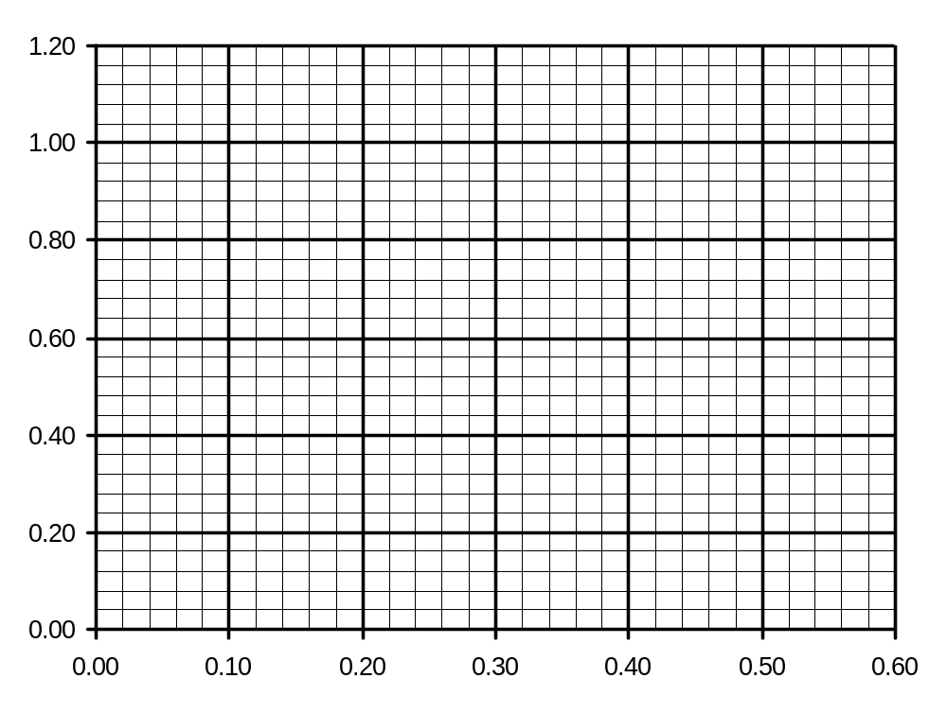
Fig. 7.1
I /A
V/V /A

- Calculate the resistance of the lamp for a potential difference across the lamp of 0.30 V.

resistance = ………………….. Ω [2]

- By reference to Fig. 7.1, state and explain qualitatively the change in the resistance of the lamp as the potential difference across the lamp is changed.
………..………..………..………..………..………..………..………..………..……..
………..………..………..………..………..………..………..………..………..……..
………..………..………..………..………..………..………..………..………..……..
……..………..………..………..………..………..………..………..………..……..[2]

- Two lamps, each having the I-V characteristic shown in Fig. 7.1, are connected first in series and then in parallel with a battery of e.m.f. 0.60 V and negligible internal resistance.
Complete the table of Fig. 7.2 for the lamps connected to the battery.

 | p.d. across each lamp/ V | Resistance of each lamp/ Ω | Total power output of lamps / W
lamps connected in series
lamps connected in parallel

Fig. 7.2. [3]

- The spontaneous and random decay of a radioactive substance involves the emission of either α-radiation or β-radiation and/or γ-radiation.

- Explain what is meant by

- spontaneous decay,
………..………..……..………..………..………..………..………..………..……..
……..………..……..………..………..………..………..………..………..……..[2]
- random decay.
………..………..……..………..………..………..………..………..………..……..
..……..………..……..………..………..………..………..……..……..………...[2]

- State the type of emission, one in each case, that

- is not affected by electric and magnetic fields,
....………..………..………..………..………..………..……..……..………...[1]
- produces the greatest density of ionisation in a medium,
....………..………..………..………..………..………..……..……..………...[1]
- does not directly result in a change in the proton number of the nucleus,
....………..………..………..………..………..………..……..……..………...[1]

